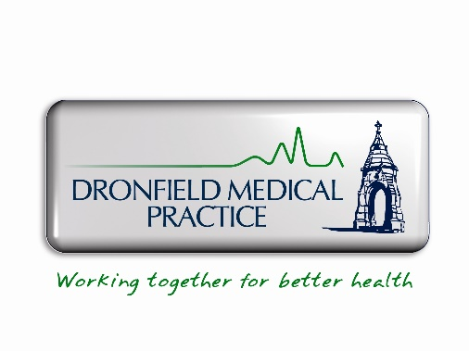

Patients with an Out of Area (OOA) Registration
Historically we accepted patients from outside of our catchment and you have been identified as one of these patients. This was called 'Out of Area' (OOA) registration. The practice withdrew from this scheme in 2024 and we no longer accept new OOA registrations. As you have previously been accepted, we do not require you to leave at this time, but we are not accepting any future OOA registrations.
What if I move again – to an address outside of the catchment area?
If you should move again outside our catchment area, we would ask you to register elsewhere. This is consistent with patients who are currently registered in our catchment area, who will also need to change GP if they move outside the catchment area. We cannot favour you because you are a current OOA patient.
What if I move again – to an address inside of the catchment area?
If you should move again to within our catchment area, we would be able to register you with the practice.
What if I have another child?
As we no longer accept OOA registrations, we are not able to register new babies for parents living out of catchment. Best practice is for parents and children to be registered at the same GP if possible, therefore we would suggest you register at a new GP surgery local to where you and your child reside.
Why have you written to me now?
We are finding that many OOA patients are upset when they are asked to leave having moved house, often asking 'I'm already out of catchment – why can't I stay?'. The answer is that by allowing OOA patients to move again outside of our area and remain registered we are prioritising them over an in-catchment patient that would also have to move. Equally we cannot prioritise a newborn baby over another patient. We're sorry, we must be fair to all patients.
Why have we had to change the policy?
We are contractually obliged to take registrations from patients residing in our catchment area. The recent extension of housing in our catchment area means that we must take these patients if they request to join our list.

Our surgery is at capacity in terms of space. Every clinic room is occupied and there is no room for us to expand within our building. If we continue to grow, we will need to employ more staff to manage patients' needs, but we have nowhere to house these staff.
Ther Partners therefore have made the difficult decision to withdraw from the Out of Area scheme to ensure that the patient list remains at a manageable level and that standards of care are maintained.
Please be aware this policy will apply to all patients equitably. We are not able to consider 'special circumstances'. Many patients feel that they have a stronger reason to remain with the practice and it is not fair to pick and choose between patients. We recognise that this will be upsetting and apologise for any distress this may cause.

What can I do to help?
Please write to your MP to ask them to ensure that GP practices get the support they need to expand their services. In our case we need funding and extra estate space to grow our services to meet demand.

